Take Home Activity 07
Student Number - 35040

Q1

public class Calculator {

int add(int a, int b) {
int result = a + b;
System.out.println("Int sum: " + result);
return result;
}

double add(double a, double b) {
double result = a + b;
System.out.println("Double sum: " + result);
return result;
}

int add(int a, int b, int c) {
int result = a + b + c;
System.out.println("Three-int sum: " + result);
return result;
}

String add(String a, String b) {
String result = a + b;
System.out.println("String join: " + result);
return result;
}
}

public class Main {
public static void main(String[] args) {

Calculator calc = new Calculator();

calc.add(10, 20);
calc.add(5.5, 4.5);
calc.add(10, 20, 30);
calc.add("Hello ", "Java");
}
}

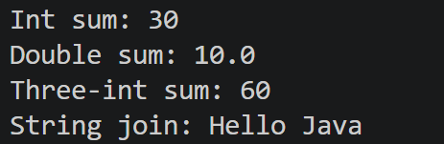

Q2

package Q2;

public class Printer {

void printData(String text) {
System.out.println("Printing text: " + text);
}

void printData(int number) {
System.out.println("Printing number: " + number);
}

void printData(String text, int copies) {
System.out.println("Printing " + copies + "copies of: " + text);
}

void printData(boolean isDuplex) {
System.out.println("Duplex printing: " + isDuplex);
}
}

package Q2;

public class Main {
public static void main(String[] args) {
Printer p1 = new Printer();

p1.printData("Hello");
p1.printData(18);
p1.printData("Navitha,18");
p1.printData(true);
}
}

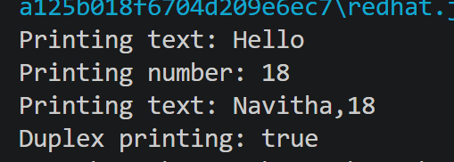

Q3

package Q3;

public class Animal {
String name;
void makeSound(){
System.out.println(name + "makes a generic sound");
}
}

class Dog extends Animal {
@Override
void makeSound(){
System.out.println(name + " says Woof! ");
}
}

class Cat extends Animal {
@Override
void makeSound(){
System.out.println(name + " says Meow! ");
}
}

class Bird extends Animal {
@Override
void makeSound() {
System.out.println(name + " says Tweet! ");
}
}

package Q3;

public class Main {
public static void main(String[] args){
Dog dog = new Dog();
dog.name = "Rex";
dog.makeSound();

Cat cat = new Cat();
cat.name = "Luna";
cat.makeSound();

Bird bird = new Bird();
bird.name = "Tweety";
bird.makeSound();

Animal a1 = new Dog();
a1.name = "Bruno";
a1.makeSound();

Animal a2 = new Cat();
a2.name = "Kitty";
a2.makeSound();

Animal a3 = new Bird();
a3.name = "Sky";
a3.makeSound();
}
}

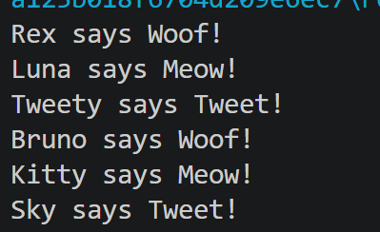

Q4

package Q4;

public class Shape {
void draw() {
System.out.println("Drawing a generic shape");
}

void area() {
System.out.println("Area: 0.0");
}
}

package Q4;

public class Circle extends Shape {
double radius;

Circle(double radius) {
this.radius = radius;
}

@Override
void draw() {
System.out.println("Drawing a Circle");
}

@Override
void area() {
double result = Math.PI * radius * radius;
System.out.println("Area: " + result);
}
}

package Q4;

public class Rectangle extends Shape {
double width;
double height;

Rectangle(double width, double height) {
this.width = width;
this.height = height;
}

@Override
void draw() {
System.out.println("Drawing a Rectangle");
}

@Override
void area() {
double area = width * height;
System.out.println("Area: " + area);
}
}

package Q4;

public class Triangle extends Shape {
double base;
double height;

Triangle(double base, double height) {
this.base = base;
this.height = height;
}

@Override
void draw() {
System.out.println("Drawing a Triangle");
}

@Override
void area() {
double area = 0.5 * base * height;
System.out.println("Area: " + area);
}
}

package Q4;

public class Main {
public static void main(String[] args) {
Shape[] shapes = new Shape[3];

shapes[0] = new Circle(5);
shapes[1] = new Rectangle(4, 6);
shapes[2] = new Triangle(3, 8);

for (Shape s : shapes) {
s.draw();
s.area();
System.out.println();
}
}
}

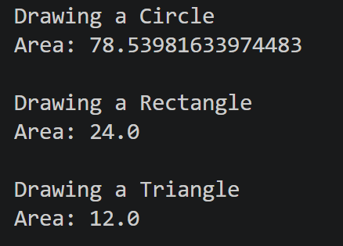

Q5

package Q5;

public class BankAccount {
String accountNumber;
String holderName;
double balance;

void showDetails(){
System.out.println("Account: " +accountNumber+ " Holder: " +holderName+ " Balance " +balance);
}

void deposit( double amount){
balance = balance + amount;
System.out.println("New balance: " + balance);
}

void deposit(double amount, String currency){
if (currency == "USD"){
balance += (amount * 300);
System.out.println("Deposited " + amount + currency + " = " + " LKR " + amount * 300 + ". New Balance: " + balance);
}
}
}

package Q5;

public class SavingsAccount extends BankAccount {
double interestRate;
@Override
void showDetails(){
System.out.println("Account: " + accountNumber + " | Holder: " + holderName + " | Balance: " + balance + " | Type: Savings | Rate: " + interestRate + "%");

}
void applyInterest(){
balance += balance * interestRate / 100;
System.out.println("Interest applied. New Balance: " + balance );
}
}

package Q5;

public class LoanAccount extends BankAccount{
double loanAmount;

@Override
void showDetails(){
System.out.println("Account: " + accountNumber + " | Holder: " + holderName + " | Balance: " + balance + " | Type: Loan | Loan: " + loanAmount);
}

void repayLoan(double amount){
loanAmount -= amount;
System.out.println("Loan repaid: " + amount + ". Remaining: " + loanAmount);
}
}

package Q5;

public class Main {
public static void main(String[] args) {

SavingsAccount s1 = new SavingsAccount();
s1.accountNumber = "SA-001";
s1.holderName = "Alice";
s1.balance = 5000;
s1.interestRate = 3.5;

s1.showDetails();
s1.deposit(1000.0);
s1.deposit(50.0, "USD");
s1.applyInterest();

System.out.println();

BankAccount b1 = new SavingsAccount();
b1.accountNumber = "SA-001";
b1.holderName = "Alice";
b1.balance = 5000;

((SavingsAccount) b1).interestRate = 3.5;
b1.showDetails();

BankAccount b2 = new LoanAccount();
b2.accountNumber = "LA-002";
b2.holderName = "Bob";
b2.balance = 0;

((LoanAccount) b2).loanAmount = 20000;
b2.showDetails();
}
}

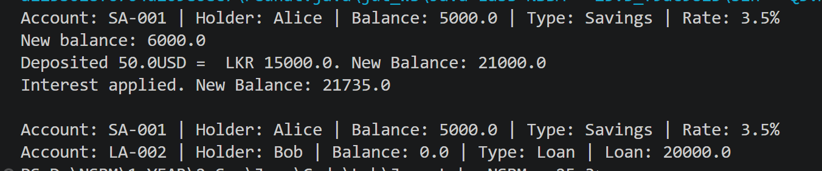
Q6

package Q6;

public class SecurityAlert {
String alertId;
String source;
String severity;

void logAlert() {
System.out.println("[ALERT] ID: " + alertId + " | Source: " + source + " | Severity: " + severity);
}

void logAlert(String extraInfo) {
System.out.println("[ALERT] ID: " + alertId + " | Source: " + source + " | Severity: " + severity + " | Info: " + extraInfo);
}

void logAlert(String extraInfo, boolean sendEmail) {
System.out.println("[ALERT] ID: " + alertId + " | Source: " + source + " | Severity: " + severity + " | Info: " + extraInfo);

if (sendEmail) {
System.out.println("Email notification sent for " + alertId);
}
}

void raiseAlert() {
System.out.println("!! SECURITY ALERT !! " + alertId + " from " + source);
}
}

package Q6;

public class MalwareAlert extends SecurityAlert {
String malwareType;

@Override
void raiseAlert() {
System.out.println("[MALWARE] " + malwareType + " detected from " + source + "!");
}

void quarantine() {
System.out.println("Quarantining " + malwareType + " from " + source + "...");
}
}

package Q6;

public class PhishingAlert extends SecurityAlert {
String targetEmail;

@Override
void raiseAlert() {
System.out.println("[PHISHING] Attack targeting " + targetEmail + " from " + source + "!");
}

void blockEmail() {
System.out.println("Blocking phishing email targeting: " + targetEmail);
}
}

package Q6;

public class DDoSAlert extends SecurityAlert{
int packetCount;

@Override
void raiseAlert() {
System.out.println("[DDoS] " + source + " - " + packetCount + " packets!");
}

void mitigate() {
System.out.println("Mitigating DDoS from " + source + " -" + packetCount + " packets dropped");
}
}

package Q6;

public class Main {
public static void main(String[] args) {

MalwareAlert m1 = new MalwareAlert();
m1.alertId = "ALT-001";
m1.source = "192.168.1.5";
m1.severity = "Critical";
m1.malwareType = "Ransomware";

m1.logAlert();
m1.logAlert("Encrypted 3 files");
m1.logAlert("Encrypted 3 files", true);
m1.raiseAlert();
m1.quarantine();

System.out.println();

SecurityAlert[] alerts = new SecurityAlert[3];

MalwareAlert malware = new MalwareAlert();
malware.alertId = "ALT-001";
malware.source = "192.168.1.5";
malware.severity = "Critical";
malware.malwareType = "Ransomware";

PhishingAlert phishing = new PhishingAlert();
phishing.alertId = "ALT-002";
phishing.source = "evil.com";
phishing.severity = "High";
phishing.targetEmail = "admin@nsbm.ac.lk";

DDoSAlert ddos = new DDoSAlert();
ddos.alertId = "ALT-003";
ddos.source = "10.0.0.99";
ddos.severity = "Critical";
ddos.packetCount = 50000;

alerts[0] = malware;
alerts[1] = phishing;
alerts[2] = ddos;

for (SecurityAlert alert : alerts) {
alert.logAlert();
alert.raiseAlert();
System.out.println();
}
}
}

